Q1.
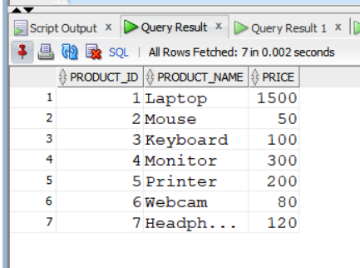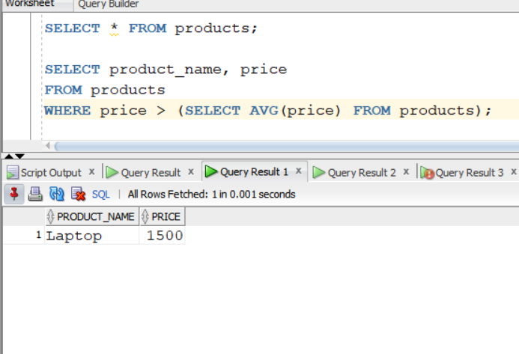
Answer is A.

B: AVG(price) is an aggregate function and cannot be used directly in a WHERE clause.

C: HAVING is only used with GROUP BY to filter group level, not individual rows.

D: The syntax is invalid.Cannot write AVG(SELECT ...).
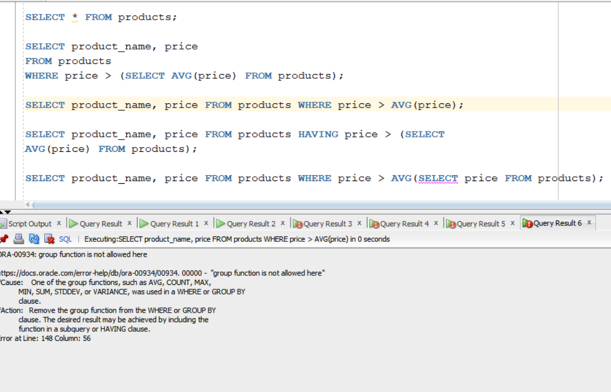

Q2.
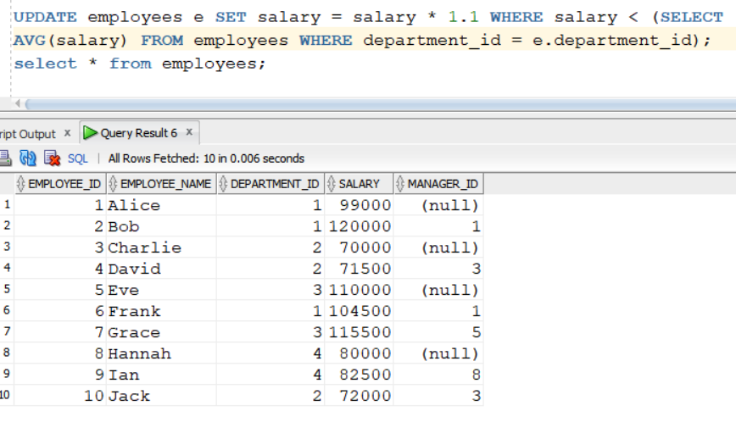
Answer is A.

B: GROUP BY does not work in UPDATE.

C: AVG(SELECT salary ...) is not valid SQL. You cannot put a SELECT inside AVG() like this.

D:
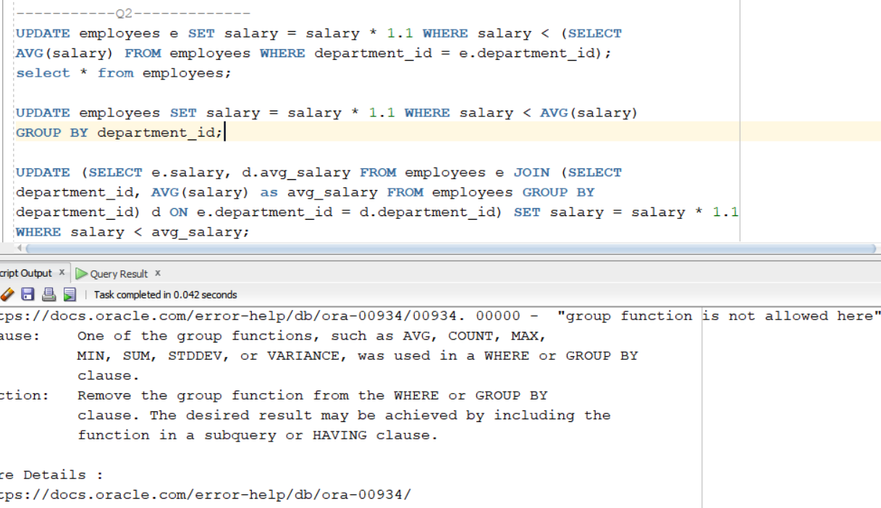

Q3.
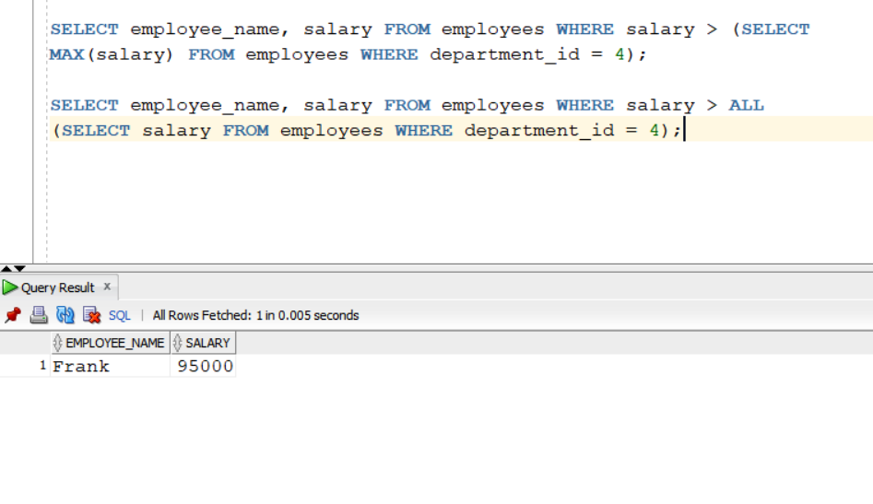
Answer is B.

A is also correct.

C: > ANY means salary is greater than at least one IT salary, not necessarily all.

D: Also work.
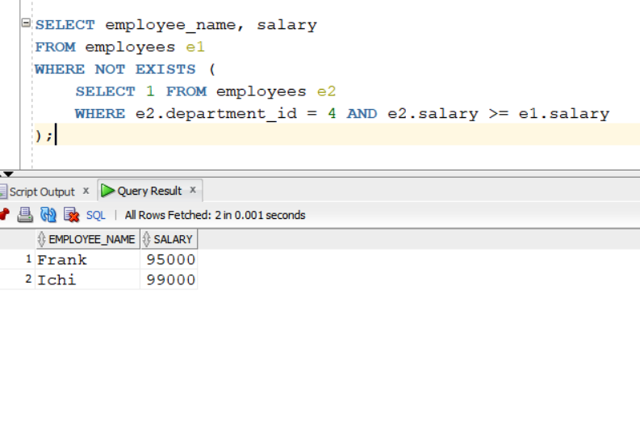

Q4.
Answer is B.

A: also correct.

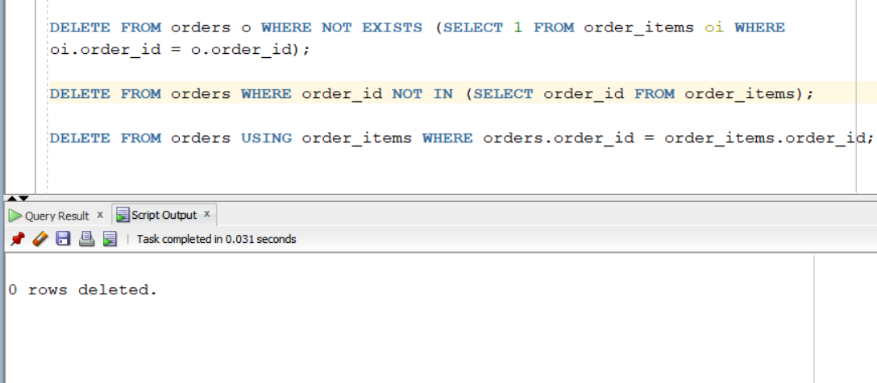

B: NOT EXISTS checks that there is no row in order_items matching the current order.Correct one.
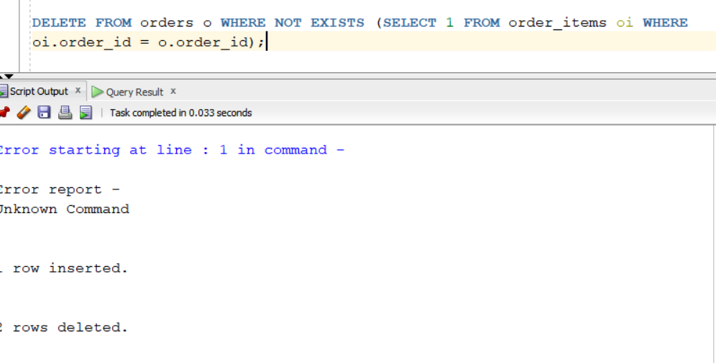

C: This deletes orders that DO have matching rows in order_items. This is not correct for question.

D: also delets orders that have matching rows in order_items. This is worng.

Q5.
Answer is A.

A: Simple and correct.
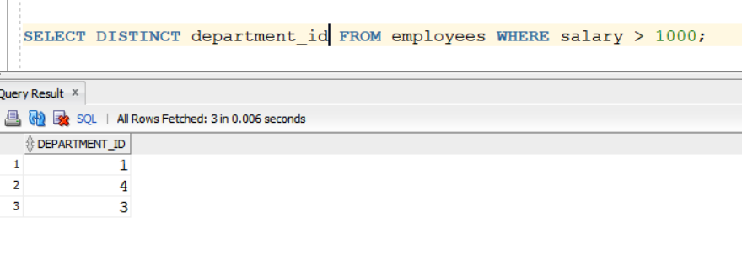

B: This is also correct.
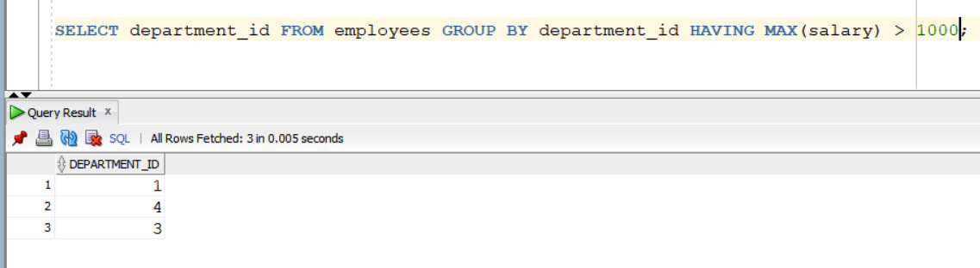

C: can produce duplicate departments unless you use DISTINCT.

D: also work but it may return duplicate.

Q6.
Answer is C.

A: also work, correct.
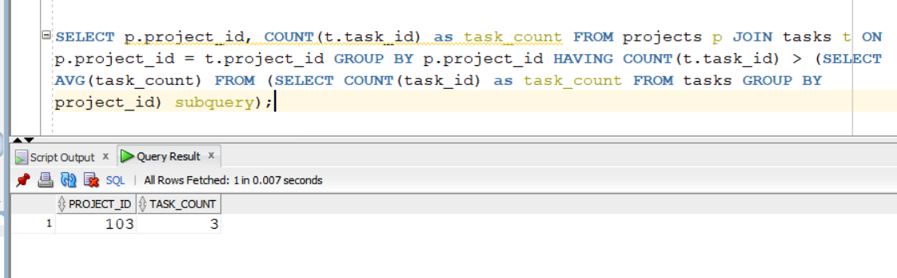

B: Syntax error.
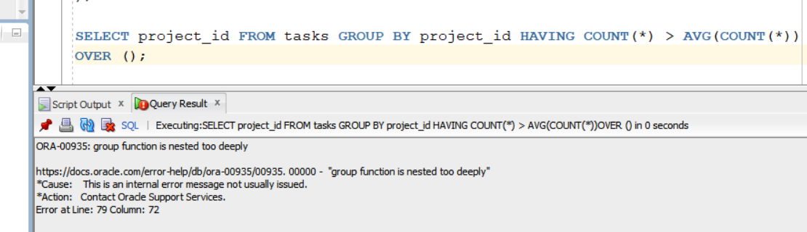

C: it is correct one.
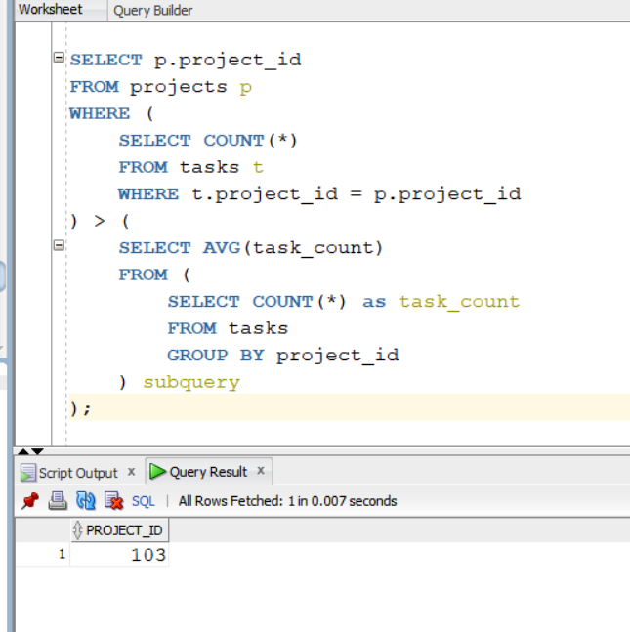

D: 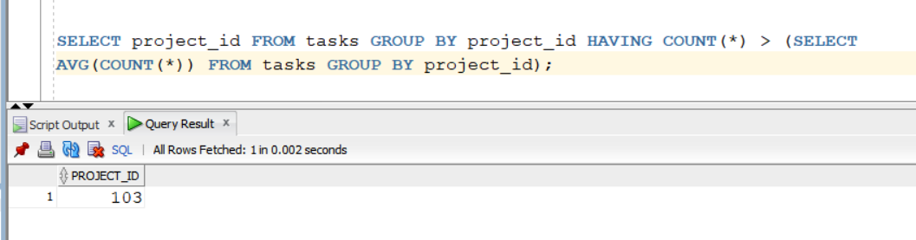

Q7.
Answer is A.

A:

